**Date** : 17/10/2023

**Project ID:**Proj_223333_Team_4

**Project name:** Traffic management

**Phase 3**

**Traffic management AI&ADS**

Traffic management AI and ADS (Autonomous Driving Systems) are two crucial technologies in the field of transportation and urban planning.

**Traffic Management AI**: Traffic management AI refers to the use of artificial intelligence to optimize traffic flow, reduce congestion, and improve overall transportation efficiency. It involves the use of various data sources, such as traffic cameras, sensors, and real-time data, to make informed decisions. AI algorithms can predict traffic patterns, adjust traffic signal timings, and even coordinate with autonomous vehicles to maintain smooth traffic flow.

**Autonomous Driving Systems (ADS):** ADS, or self-driving vehicles, are an advanced technology that has the potential to revolutionize transportation. These systems use a combination of sensors, cameras, and AI to navigate and control vehicles without human intervention. They can communicate with each other and traffic management systems to enhance safety and traffic flow.

The synergy between Traffic Management AI and ADS can lead to several benefits:

**Reduced Congestion:** AI can optimize traffic flows, and autonomous vehicles can drive more efficiently, reducing traffic congestion.

**Improved Safety**: ADS can react quickly to potential accidents or hazards, reducing accidents caused by human error.

**Energy Efficiency**: AI can help optimize routes, and autonomous vehicles can drive more fuel-efficiently, leading to reduced energy consumption.

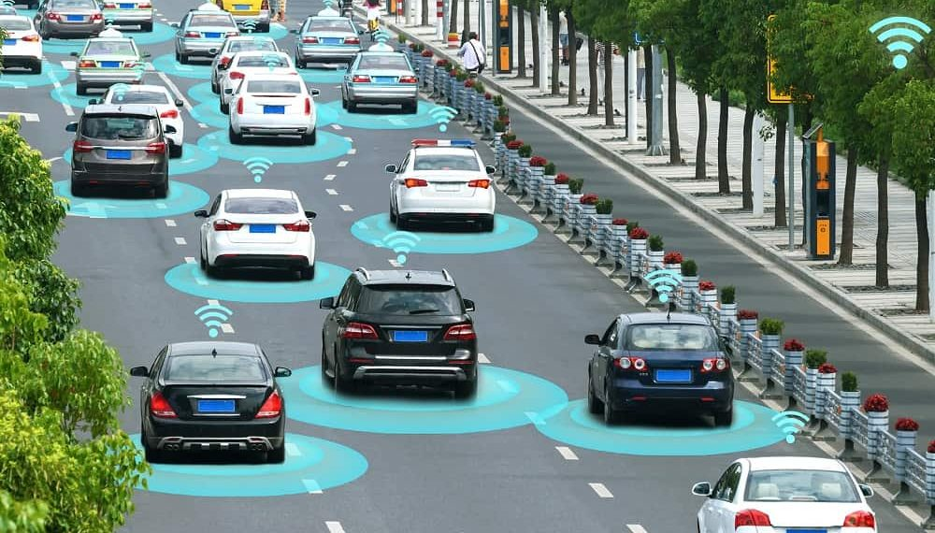

**Reduced Emissions**: Optimized traffic and more efficient driving can lead to reduced greenhouse gas emissions.

**Enhanced Mobility**: AI can provide real-time traffic information, aiding in route planning, and autonomous vehicles can increase mobility options, especially for individuals with limited mobility.

**Urban Planning**: Traffic management AI can help city planners make data-driven decisions about transportation infrastructure and policies.

However, it’s important to note that these technologies also come with challenges related to data privacy, security, and the need for new regulations and infrastructure updates. Collaboration between AI developers, automakers, urban planners, and government bodies is essential to harness the full potential of Traffic Management AI and ADS for sustainable and efficient transportation.

**Traffic management DAS**

DAS typically stands for “Distributed Antenna System,” which is used to improve cellular and wireless coverage in areas with high traffic. In the context of traffic management, a Traffic Management DAS could refer to a system that uses distributed antennas to enhance communication and data transfer for traffic monitoring, control, and management, ensuring a more efficient flow of information and services for transportation agencies and authorities. This technology can aid in real-time traffic data collection, surveillance, and communication for traffic management purposes.

**Traffic Management OT**

UserTraffic management Traffic management can refer to a variety of activities related to controlling and regulating the flow of traffic on roads and other transportation networks. It often involves strategies like traffic signals, road signs, speed limits, lane designations, and more to ensure safe and efficient movement of vehicles and pedestrians. If you have a specific question or need information on a particular aspect of traffic management, please provide more details.

**Traffic management CAD (Computer-Aided Design)**

refers to the use of CAD software and technology in the field of traffic management and engineering. This software is used to design, plan, and analyze various aspects of traffic systems and infrastructure, such as road layouts, traffic signal placement, and signage. It helps traffic engineers and urban planners create efficient and safe transportation systems. If you have specific questions or need information on a particular aspect of traffic management CAD, please provide more details.

Traffic management CAD (Computer-Aided Design) refers to the use of CAD software and technology in the field of traffic management and engineering. This software is used to design, plan, and analyze various aspects of traffic systems and infrastructure, such as road layouts, traffic signal placement, and signage. It helps traffic engineers and urban planners create efficient and safe transportation systems. If you have specific questions or need information on a particular aspect of traffic management CAD, please provide more details.

